**DAILY ONLINE ACTIVITIES SUMMARY**

|  |  |  |  |  |  |  |  |  |
| --- | --- | --- | --- | --- | --- | --- | --- | --- |
| **Date:** | **14-07-2020** | | | | | **Name:** | **Veekshith shetty** | |
| **Sem & Sec** | **8th sem B sec** | | | | | **USN:** | **4AL16CS097** | |
| **Online Test Summary** | | | | | | | | |
| **Subject** | | **-** | | | | | | |
| **Max. Marks** | | **-** | | **Score** | | | **-** | |
| **Certification Course Summary(Internship)** | | | | | | | | |
| **Course** | **Alexa for developers** | | | | | | | |
| **Certificate Provider** | | | **aws** | | **Duration** | | | **3 hrs** |
| **Coding Challenges** | | | | | | | | |
| **Problem Statement: The java program throws clause in exception handling with default messages** | | | | | | | | |
| **Status: completed** | | | | | | | | |
| **Uploaded the report in Github** | | | | | **yes** | | | |
| **If yes Repository name** | | | | | **Veekshith-Shetty** | | | |
| **Uploaded the report in slack** | | | | | **yes** | | | |

Online Test Details: (Attach the snapshot and briefly write the report for the same)

Certification Course Details: (Attach the snapshot and briefly write the report for the same)

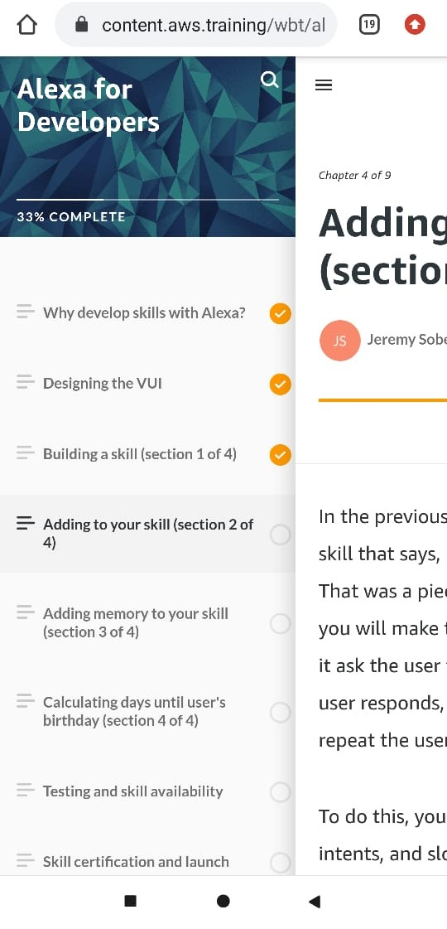

Coding Challenges Details: (Attach the snapshot and briefly write the report for the same)

Coding was given n it was uploaded for github and slack

PROGRAM1

import java.lang.*;

public class Demonstration_1010 {

public static void main(String Args[]) throws Exception{

int[] array = new int[3];

try{

for (int i=0;i<4;++i)

{

array[i] = i;

}

System.out.println(array);

}

catch(ArrayIndexOutOfBoundsException e){

System.out.println("filIn: " + e.fillInStackTrace());

System.out.println("cause: " + e.getCause());

System.out.println("local: " + e.getLocalizedMessage());

System.out.println("messa: " + e.getMessage());

System.out.println("trace: " + e.getStackTrace());

System.out.println();

System.out.println();

System.out.print("trace: ");

e.printStackTrace();

System.out.println();

System.out.print("string: ");

e.toString();

System.out.println();

System.out.println();

//printed just to inform that we have entered the catch block

System.out.println("Oops, we went too far, better go back to

0!");

throw (Exception) new Exception().initCause(e);

}

finally{

System.out.println(array);

// method call to continue program

}

}

}

|  |
| --- |
|  |